# Output

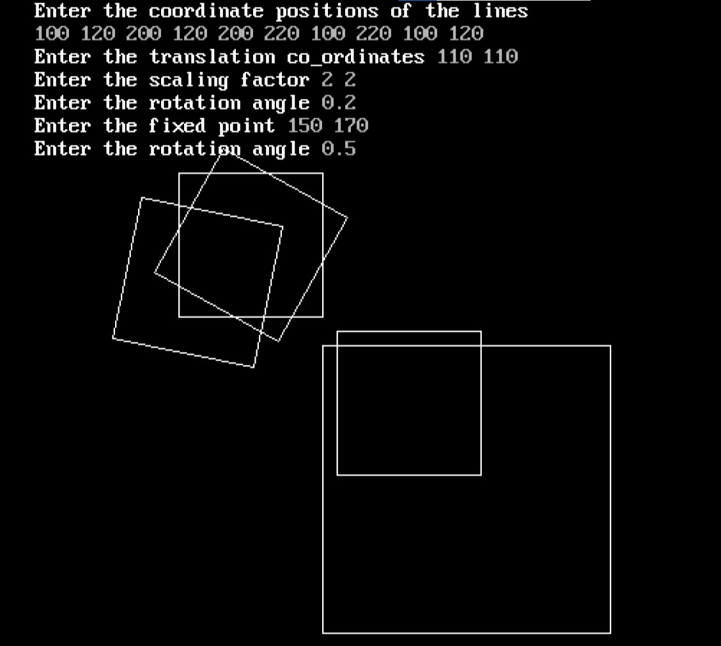

# Discussion

A C program was written in Turbo C++ using the graphics.h library and its various available functions and methods. In this lab, the various types of transformation of a point was illustrated like translation, rotation, reflection, etc. The algorithms and transformation of a point was studied in detail and implemented in the program. Firstly, a single point was transformed and the output was observed. The translation translated the co-ordinates of the point to a calue that was specified by the user. Similarly, the rotation and scaling of the point was also done and visualized.

Using these transformation methods, a rectangle was transformed into various points and shapes. First, a rectangle was drawn using the points specified by the user and the value of translation, scaling and rotation was asked from the user respectively. The rectangle after these operations were shown in the screen simultaneously with all the previous output as shown in the above output section. Finaly, a fixed point rotation operation was also performed that included some additional steps of translation before rotating the rectangle. After all these operations, the 2D transformation operation were successfully implemented in the program.

# Conclusion

Thus, various methods and types of 2d transformation can be studied and implemented in the program.